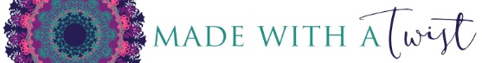
Noncompete / Nondisclosure Agreement

___________________ agrees not to copy, disclose, discuss, share or allow direct or indirect access to others, the pattern for which she is testing, a pattern copyrighted by Made with a Twist, or any confidential information obtained during voluntary contract work related to this product performed for Pamela Grice, Montgomery Grice Enterprises, Inc., Made with a Twist or Crochetpreneur.

________________ also agrees not to engage in the production for sale or design of any similar product or pattern that would compete with any test design either during or following the contract work performed for Pamela Grice Montgomery Grice Enterprises, Inc., Made with a Twist or Crochetpreneur without written permission of Pamela Grice a/k/a Made with a Twist / Montgomery Grice Enterprises, Inc.

_________________ understands that violation of these terms would result in irreparable harm to Montgomery Grice Enterprises, Inc., Made with a Twist and/or Crochetprneur and same would be entitled to seek any and all legal options to enforce the terms of this agreement.

This __________day of ______________, 2018.

(contracter)

Pamela Grice, President and Owner
Made with a Twist / Montgomery Grice Enterprises, Inc.

